Empirical Evaluation of Machine-Learning and Software-Observable Side-Channel Leakage in QEQSKE
Project Report Submitted in Partial Fulfilment of the Requirements for the Degree of
Bachelor of Technology
in
Computer Science and Engineering
Submitted by
Name of the Student1: Sri Surya Srikar (Roll No. 2310110666)
Name of the Student2: Sashreek Kandagatla (Roll No. 2310110266)
Name of the Student3: Sane Yateesh Reddy (Roll No. 2310110673)
Under the Supervision of
Prof. Rajib Mall
Professor, Department of Computer Science and Engineering

Shiv Nadar University, Delhi NCR
Department of Computer Science and Engineering
October, 2026

Declaration
I/We declare that this written submission represents my ideas in my own words and where others' ideas or words have been included, I have adequately cited and referenced the original sources. I also declare that I have adhered to all principles of academic honesty and integrity and have not misrepresented or fabricated or falsified any idea/data/fact/source in my submission. I understand that any violation of the above will be cause for disciplinary action by the University and can also evoke penal action from the sources which have thus not been properly cited or from whom proper permission has not been taken when needed.
Name of the Student: SRI SURYA SRIKAR
Signature and Date: ______________________________
Name of the Student: SASHREEK KANDAGATLA
Signature and Date: ______________________________
Name of the Student: SANE YATEESH REDDY
Signature and Date: ______________________________

Abstract
QEQSKE (Quantum Enabled Quantum Safe Key Exchange) is HCL Software's patented post-quantum key-exchange construction, combining a hardware Quantum Random Number Generator (QRNG) with CRYSTALS-Kyber (standardized by NIST as ML-KEM, FIPS 203). Because QEQSKE has no public reference implementation, its practical side-channel and machine-learning-based attack surface has not previously been evaluated in open literature. This report presents an empirical security assessment built from scratch in Python/NumPy at toy parameters (n = 4, k = 2), addressing five research questions through four attack scenarios: an ML distinguisher against QRNG-derived randomness (Attack A, evaluated at three levels of increasing relevance to QEQSKE's own pipeline), an entropy-leakage / reconstruction test (Attack B), a software-observable side-channel study combining timing, memory, and CPU signals (Attack C), and a planned fault-injection study (Attack D, not yet performed).
Across all completed attacks, no exploitable leakage was detected under the tested conditions. All six models evaluated in Attack A, Level 1 (Random Forest, SVM, XGBoost, LSTM, GRU, Transformer) are reported with accuracy, ROC-AUC, precision, recall, F1, mean ± SD and t-distribution 95% confidence intervals computed over repeated cross-validation or repeated holdout splits (Section 5.3), rather than from a pooled sample count. No statistically significant distributional difference was detected in the tested QEQSKE-derived observables after multiple-comparison correction, public outputs alone did not provide a predictive advantage over the majority-class baseline, and combined side-channel classifiers stayed within a few percentage points of baseline across a five-level progressive difficulty ladder. A positive-control experiment — an intentionally leaky QEQSKE variant — was detected with 100% accuracy and ROC-AUC = 1.0 by the identical pipeline, showing that the measurement apparatus can detect a substantial leak and that the negative results elsewhere are not simply the product of an insensitive pipeline. QEQSKE-clean also behaved comparably to a real, standardized ML-KEM-512 implementation (kyber-py) under the same pipeline.
These results should not be interpreted as a proof of QEQSKE's security: the evaluation uses toy cryptographic parameters, a non-constant-time pure-Python implementation, software proxies rather than physical power/EM/cache measurements, and has not evaluated decapsulation or fault injection. The principal contribution is therefore an empirical demonstration that no exploitable leakage was detected under the tested conditions, together with a statistically rigorous and reproducible methodology — null-hypothesis framing, fold-level confidence intervals, permutation tests, multiple-comparison correction, effect-size reporting, and positive-control validation — for extending the evaluation toward production-scale QEQSKE implementations.

1 Introduction

1.1 Motivation
The prospect of large-scale quantum computers has driven a global transition toward post-quantum cryptography (PQC) [1]; NIST standardized CRYSTALS-Kyber as ML-KEM (FIPS 203) [2] in August 2024. HCL Software has developed QEQSKE, a patented modification of Kyber that additionally sources its randomness from a hardware QRNG rather than a classical PRNG, intended to strengthen the protocol's randomness guarantees. Mathematical hardness, however, is only one half of real-world security: major PQC candidates, including standard Kyber/ML-KEM, have been attacked in practice not through cryptanalysis of the underlying Learning-With-Errors (LWE) problem [3] but through side-channel leakage. QEQSKE is a pre-deployment industrial system, so an empirical assessment of its practical attack surface before wider adoption is of direct value to HCL Software.
The Kyber/ML-KEM side-channel literature (Section 2.4) shows hardware-executed implementations broken with high accuracy via deep-learning side-channel analysis, raising the question of whether analogous weaknesses are detectable even under a software-only threat model. Prior QRNG-cryptanalysis work (Truong et al. [4]) has shown that ML can predict QRNG output better than chance under some conditions, establishing ML-based QRNG distinguishing as a legitimate, previously demonstrated research question.

1.2 Problem Statement and Research Questions
Can an adversary who observes only QEQSKE's public outputs, or only software-observable execution signals (timing, memory, CPU usage) — without physical instrumentation such as oscilloscopes or EM probes — extract exploitable information about the secret key material or distinguish QRNG-derived randomness from ordinary pseudo-randomness, even though the underlying lattice problem is believed quantum-resistant?
Five research questions (RQ1–RQ5) were defined, each paired with a null hypothesis (H0) that the corresponding attack experiment tests, making explicit what evidence would be required to reject it.
Table 1.1 lists the five research questions, the null hypothesis tested by each, the experiment that addresses it and its current status.
Table 1.1. Research questions and their corresponding null hypotheses.
RQ | Null hypothesis (H0) | Experiment | Status
RQ1 | QRNG-derived and PRNG-derived (Mersenne Twister) data are indistinguishable by ML models. | Attack A (Levels 1–3) | Complete
RQ2 | QRNG data contains no reconstructable / compressible structure beyond that of pure randomness. | Attack B | Complete
RQ3 | Software-observable execution signals carry no secret-key-dependent information. | Attack C | Complete
RQ4 | Sequence models (LSTM/GRU/Transformer) provide no additional distinguishing advantage over classical models. | Attack A (Level 1) | Complete
RQ5 | Deliberate fault injection does not reveal exploitable information about the secret key. | Attack D | Not performed

1.3 Research Gap
- No published work evaluates QEQSKE specifically — a patented, unpublished modification of Kyber; this is a first empirical evaluation of that construction.
- Existing Kyber SCA literature targets hardware-executing implementations with physical trace access; this project uses only software-observable proxies, a different and more limited threat model that is stated explicitly throughout (Chapters 3 and 9).
- Existing QRNG ML-distinguisher work targets the raw entropy source in isolation; this project extends that to test whether QEQSKE's own key-generation pipeline preserves indistinguishability once QRNG output is transformed (Attack A, Level 2).

1.4 Contributions
- The first empirical, reproducible security evaluation of QEQSKE specifically, rather than Kyber/ML-KEM in general.
- A three-level ML-distinguisher design (Attack A) moving from raw randomness, to the protocol's own derived outputs, to public outputs only, testing at each level whether an adversary gains any predictive advantage.
- A statistically explicit treatment of every distinguishing claim: fold-level mean ± SD with t-distribution 95% confidence intervals, permutation tests, Fisher-z correlation intervals, Bonferroni correction, and effect sizes.
- A positive-control methodology (a deliberately leaky QEQSKE variant) validating the measurement-and-ML pipeline itself.
- An external, non-self benchmark against a real, standardized ML-KEM-512 implementation (kyber-py).
- A reproducibility package (Chapter 7) recording software versions, hardware, seeds, splits, hyperparameters and preprocessing.

1.5 Report Organisation
Chapter 2 gives background and surveys related work; Chapter 3 defines the threat model and security goals; Chapter 4 describes the experimental and statistical methodology; Chapter 5 reports results, ending with a table answering each research question; Chapter 6 discusses what the results do and do not mean; Chapter 7 provides reproducibility information; Chapter 8 sets out the timeline and plan after the mid-term; Chapter 9 lists limitations; and Chapter 10 concludes.

2 Literature Survey and Background

2.1 QEQSKE
QEQSKE couples a hardware QRNG with a Kyber-derived lattice-based KEM. Randomness from the QRNG passes through a randomness-extraction stage before being consumed by every randomness-dependent step of key generation and encryption: prime generation, secret-coefficient sampling, and encryption noise. Figure 2.1 shows the data flow and the attack surfaces evaluated. An adversary may observe QEQSKE's public outputs (the prime q, public key t and ciphertext) directly and — in a software-only threat model — the execution-time side effects of key generation and encryption (timing, memory, CPU usage), but never the secret coefficients s.
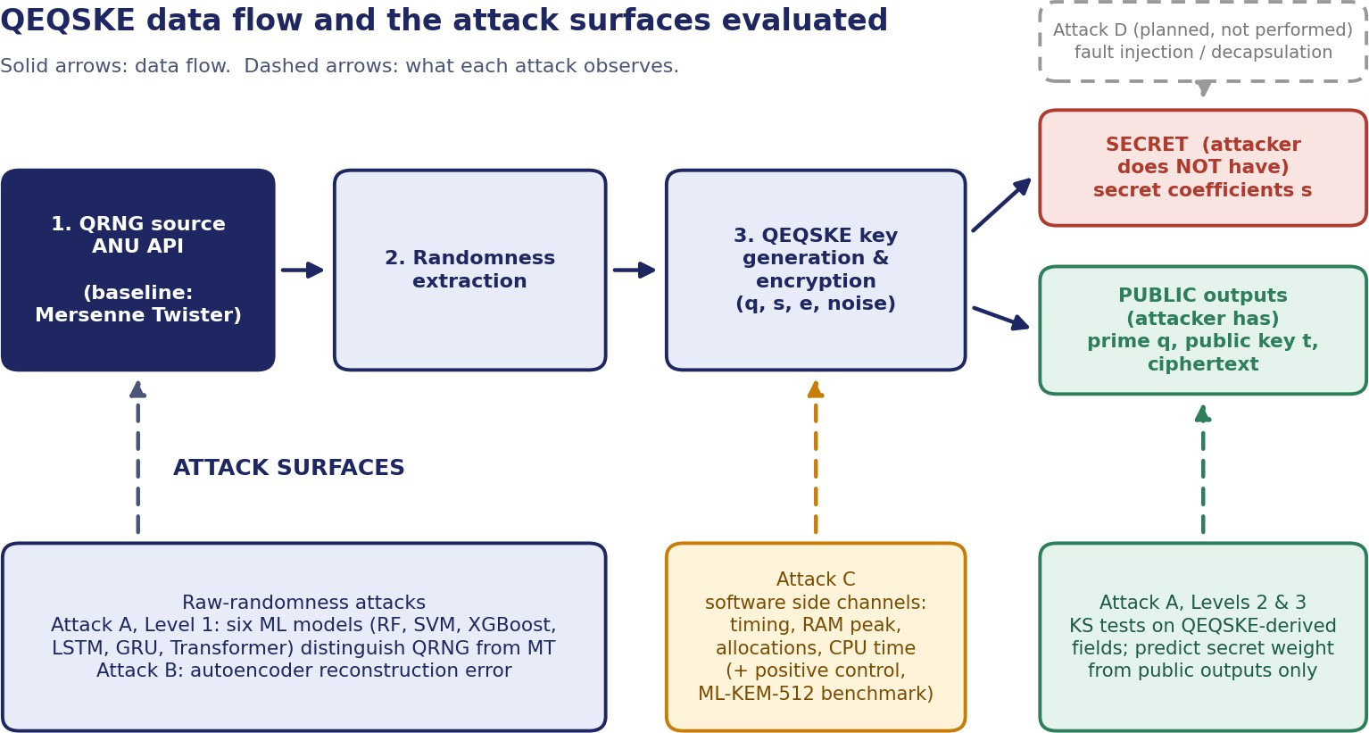
Figure 2.1. QEQSKE data flow (QRNG → extraction → key generation → public/secret outputs) and the attack surface targeted by each experiment.

2.2 ML-KEM / Kyber
CRYSTALS-Kyber, standardized as ML-KEM in FIPS 203, is a lattice-based KEM whose hardness rests on the Module Learning-With-Errors (M-LWE) problem. A key pair consists of a public key (matrix A, modulus q, public vector t = A·s + e) and a secret key (small-coefficient vector s); security depends on the difficulty of recovering s from (A, t) given only bounded errors e. QEQSKE parameterizes this as (n, k); this project used toy parameters n = 4, k = 2, far below standardized ML-KEM-512/768/1024 (n = 256), for computational tractability (Sections 4.1 and 9.1).

2.3 QRNG
A QRNG produces randomness from an intrinsically indeterministic quantum process, rather than a deterministic algorithm seeded with limited entropy as classical PRNGs do. Real QRNG hardware chains can introduce small amounts of deterministic classical noise, which is the imperfection that motivates ML-based QRNG distinguishing research. NIST SP 800-22 [5] defines the standard statistical test suite for randomness, used as this project's baseline testing (Section 5.2); NIST SP 800-90B [6] defines min-entropy estimation for physical entropy sources. Truong et al. [4] demonstrated, using a real QRNG, that ML models can predict output better than chance when the extraction process retains deterministic classical noise, which directly motivates Attack A. This project used the ANU QRNG public API [7] as its quantum randomness source.

2.4 Side-Channel Attacks
A side-channel attack exploits information leaking from physical or software-observable execution behaviour rather than attacking the underlying math. Kocher [8] first showed that microsecond-level timing variation could reveal secret-dependent branching; Kocher, Jaffe and Jun [9] introduced Differential Power Analysis (DPA), which with its correlation variant (CPA) remains the classical baseline; Yarom and Falkner [10] introduced Flush+Reload, a cache side-channel attack exploiting shared CPU cache state, and Yan, Fletcher and Torrellas [11] demonstrated a related cache-based technique ("Cache Telepathy").
Deep-learning side-channel analysis (DL-SCA) exploits high-dimensional leakage patterns that simple statistical thresholds miss, often needing far fewer traces than classical CPA. Every major published Kyber/ML-KEM side-channel result targets compiled, hardware-executing implementations with physical trace access — a materially stronger threat model than this project's. Chinbat et al. [12] reported up to 96.64% accuracy classifying Kyber secret coefficients via deep learning on an FPGA NTT accelerator's power traces, and chosen-ciphertext attacks combined with belief propagation have achieved full key recovery on ARM Cortex-M4 hardware [13, 14]. These results establish that Kyber's mathematical hardness does not guarantee implementation security, while also marking this project's more limited scope: wall-clock timing, tracemalloc and psutil, without physical equipment.
This project applies the ML technique family in two roles: as a distinguisher (classical and sequence models separating QRNG- from pseudo-random data, or predicting secret-dependent properties from public outputs) and as a leakage detector (classifying side-channel traces by a secret-key property). Both are evaluated against explicit chance-level or majority-class baselines with significance testing, not raw accuracy alone.

3 Threat Model and Security Goals
The evaluation adopts a deliberately bounded, software-only adversary model, so that the scope of every "no exploitable leakage detected" statement is unambiguous.

3.1 Adversary Capabilities
Table 3.1 lists the capabilities granted to the attacker and those that are out of scope.
Table 3.1. Threat model: capabilities granted to the attacker.
Capability | Attacker has? | Used in / note
Public key (q, t) | Yes | Attack A, Level 3
Ciphertext | Yes | Observable public output
Timing observations | Yes | Attack C (time.perf_counter on key_gen(), encrypt_it())
Memory observations | Yes | Attack C (tracemalloc peak and allocations)
CPU observations | Yes | Attack C (psutil CPU time)
QRNG / Mersenne Twister reference datasets | Yes | Attack A, B — best case for the adversary (stronger than typical)
Secret key (coefficients s) | No | Protected asset; used only as a label for evaluation
Power trace | No | Out of scope (no oscilloscope)
EM trace | No | Out of scope (no EM probe)
Cache counters | No | Out of scope; psutil CPU time is only a coarse proxy
Chosen ciphertext | No | Out of scope
Fault injection | No | Out of scope (Attack D, not performed)

The adversary may train arbitrary classical or sequence-model ML classifiers on any of the observations marked "Yes".

3.2 Security Goals
- G1 — Indistinguishable randomness. QRNG-derived inputs, and the outputs of the key-generation pipeline fed by them, should not be distinguishable from Mersenne-Twister-derived equivalents (RQ1, RQ2, RQ4).
- G2 — No leakage through public outputs. The public key and prime should not provide an adversary with a predictive advantage about secret-key properties (Attack A, Level 3).
- G3 — No leakage through software-observable execution signals. Timing, memory and CPU observations should not carry secret-key-dependent information usable by an ML classifier (RQ3).
- G4 — Robustness to decapsulation and fault attacks. Not evaluated in this study (RQ5, Attack D).

3.3 Assets and Assumptions
The protected asset is the secret coefficient vector s. The evaluation assumes the implementation is functionally correct (verified in Section 5.1) and that the QRNG/MT datasets are representative of the sources' real output distributions. The non-constant-time nature of the Python implementation is treated as a known deviation from production (Section 9.2), not a threat-model assumption.

4 Experimental Methodology
Figure 4.1 summarizes the pipeline shared by all four attacks: a randomness source (QRNG or Mersenne Twister) feeds QEQSKE key generation/encryption; timing, memory, and CPU observations are collected alongside randomness-derived outputs; features are engineered and combined; and ML models are evaluated against explicit chance-level or majority-class baselines.
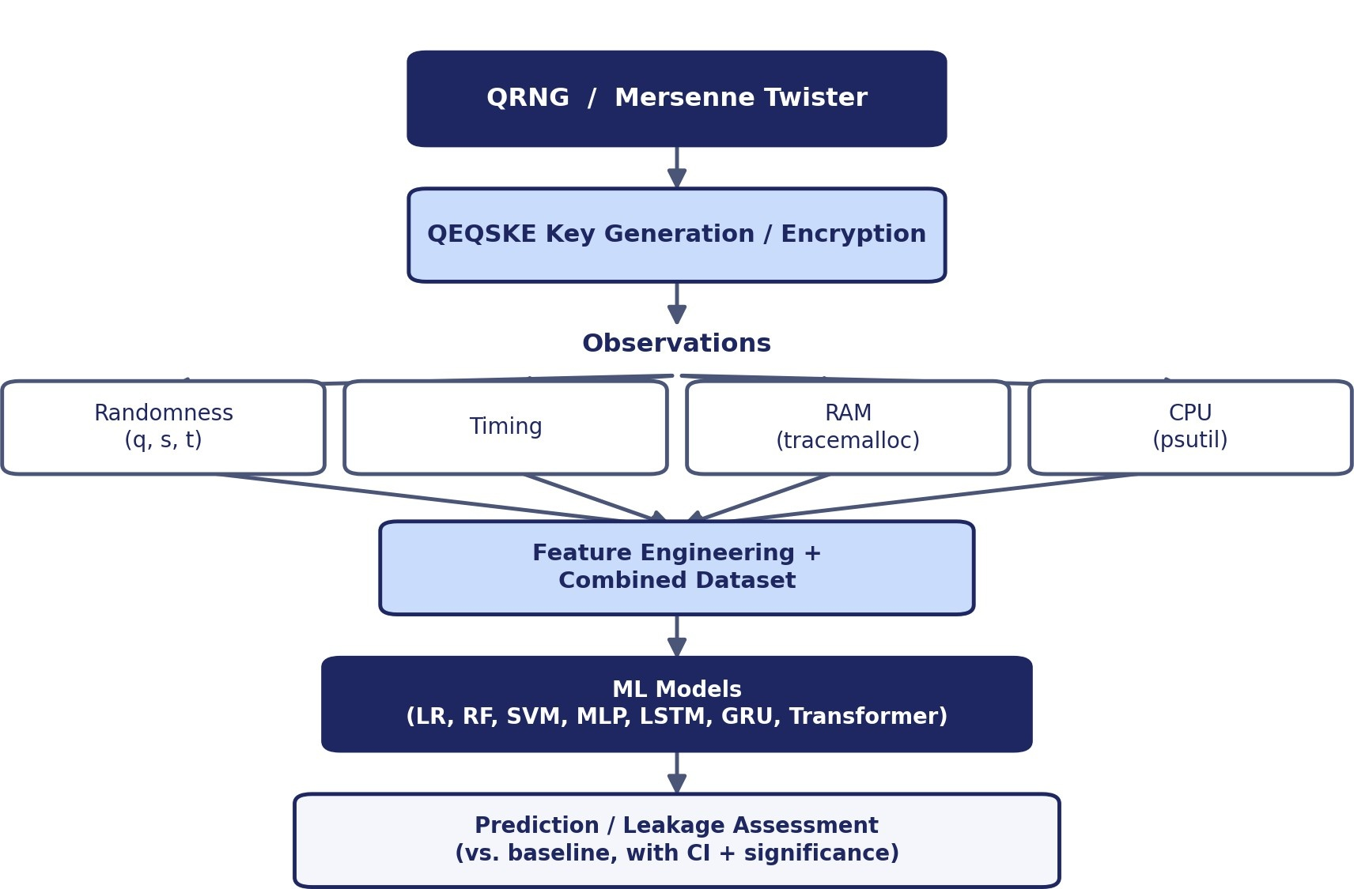
Figure 4.1. Experimental measurement and attack pipeline used across Attacks A, B, and C.
Model selection progresses from simple, interpretable baselines to increasingly expressive architectures, so that any detected signal can be attributed to genuine structure rather than an overly flexible model fitting noise, and so that a null result from complex models is itself informative (RQ4).
Table 4.1 gives the rationale for each machine-learning model family used in Attacks A and C.
Table 4.1. Rationale for each machine-learning model family used across Attacks A and C.
Model | Why included
Logistic Regression | Linear baseline.
Random Forest | Nonlinear feature interactions + feature-importance analysis.
SVM (RBF kernel) | Nonlinear kernel-based classification.
XGBoost | Strong gradient-boosted tabular baseline.
MLP | General nonlinear function approximator.
LSTM | Sequential dependency modelling; raw sequence order, not just windowed statistics.
GRU | Lightweight sequential alternative to LSTM.
Transformer | Long-range dependencies via self-attention.

4.1 Implementation
Only the QEQSKE/Kyber core and the three sequence models are custom-built; every other component uses established, standard implementations, limiting the risk of implementation bugs affecting the ML and statistical results.
Table 4.2 distinguishes the custom-built components from those that use standard, library-based implementations.
Table 4.2. Custom-built vs. standard/library-based components.
Component | Implementation used | Custom / standard
QEQSKE / Kyber core | Built from scratch (HCL Algorithms 1–10) | Custom
LSTM / GRU / Transformer | Built from scratch in pure NumPy | Custom
RF, SVM, Logistic Regression, XGBoost | scikit-learn / xgboost | Standard
Autoencoder, MLP classifiers | scikit-learn (MLPRegressor / MLPClassifier) | Standard
Significance testing | scipy.stats (pearsonr, spearmanr, ks_2samp, t, norm); sklearn permutation_test_score | Standard
Memory / CPU profiling | tracemalloc / psutil | Standard
Randomness sources | ANU QRNG API / NumPy MT19937 | Standard
Standard ML-KEM reference | kyber-py (FIPS 203) | Standard

4.2 Data
- QRNG source: ANU QRNG public API, a hardware quantum entropy source; 1,106,944 numbers collected from the ANU QRNG API (max 1,024 per request).
- Baseline: an equal-size Mersenne Twister (MT19937) dataset, used as the classical-randomness comparison point for Attacks A and B.
- Classical-model dataset (Attack A, Level 1): non-overlapping windows of 8 numbers, each summarized by 15 statistical features (mean, std, min, max, range, median, skew, bit-ones ratio, lag-1 autocorrelation, difference mean, difference std, longest bit run, entropy, mod-3 balance, even ratio), giving 276,736 labelled samples (138,368 per class).
- Sequence-model dataset (Attack A, Level 1): raw draw-order windows of 32 numbers, z-normalized per window (mean 0, standard deviation 1). Because the models are pure NumPy, they are trained on a smaller sample of windows than the classical models; the exact sample size is reported with the results (Table 5.4).
- Side-channel data (Attack C): per-trial timing (time.perf_counter), tracemalloc peak and allocation counts, and psutil CPU time, measured on key_gen() and encrypt_it() alongside the trial's secret key (500–1,000 trials for the combined dataset, 300 for the positive control).

4.3 Attack A — Three-Level ML Distinguisher
Testing only raw QRNG-vs-MT distinguishability would leave unaddressed whether the QEQSKE protocol built on that randomness leaks. Attack A therefore has three levels, jointly addressing RQ1 and RQ4.
- Level 1 (raw randomness). Six models — Random Forest, SVM, XGBoost (statistical features) and LSTM, GRU, Transformer (raw sequences, pure NumPy) — distinguish QRNG from MT. Comparing classical with sequence models tests RQ4. Classical models use RepeatedStratifiedKFold (5 folds × 5 repeats, seed 42), giving 25 fold-level estimates per metric (n_estimators = 50 for RF/XGBoost; SVM uses the RBF kernel with decision-function ROC-AUC, on a disclosed stratified subsample if full-data cross-validation was too slow). Sequence models are too slow for k-fold CV in pure NumPy, so 10 repeated 75/25 holdout splits (seeds 42–51) are used instead. A repeat counts only if the positive control — the same model trained on an intentionally autocorrelated stream — still clears its validation margin, so a broken training run cannot masquerade as a null result.
- Level 2 (QEQSKE-derived). Both sources are fed through the real key-generation pipeline; generated primes, secret-coefficient statistics, and public-key entries are compared across 300 trials per source by the two-sample Kolmogorov–Smirnov (KS) test, Bonferroni-corrected across five fields.
- Level 3 (public outputs only). An ML model sees only the prime q and public key t — no execution data — and predicts secret-key weight via repeated 5-fold × 10-repeat CV, testing whether public outputs give an adversary any advantage at this scale.

4.4 Attack B — Entropy Leakage
An autoencoder (MLPRegressor with a bottleneck) compresses and reconstructs QRNG, MT, and pure-noise data. A QRNG-to-noise reconstruction-error ratio close to 1.0 indicates no detectable compressible structure beyond ideal randomness under the chosen representation and model capacity (RQ2).

4.5 Attack C — Side-Channel Analysis
Software proxies were used (no physical equipment was available): time.perf_counter (timing), tracemalloc (memory), psutil (CPU), applied to key_gen() and encrypt_it(). Five components address RQ3: (1) individual-leg correlations; (2) a combined ML attack (timing + RAM + CPU on 500 trials, four classifiers predicting above/below-median secret weight); (3) a progressive difficulty ladder (five targets from secret-weight-binary to an individual coefficient's exact value, repeated 5-fold × 10-repeat CV, 1,000 trials); (4) a positive control (Section 4.6); (5) an external ML-KEM benchmark (Section 4.7). Both statistical significance and out-of-sample ML margin over baseline are reported for every experiment, since a signal can be significant (p < 0.05, large sample) while giving no exploitable predictive edge.

4.6 Positive Control
A "no leakage found" result is ambiguous: it could mean no exploitable side channel exists, or that the pipeline is simply insensitive. A QEQSKE-leaky variant was built with an intentional secret-dependent timing branch (triggered near the median secret weight); the identical pipeline (timing feature, 5-fold × 10-repeat CV) was run against QEQSKE-clean and QEQSKE-leaky, 300 trials each, and reproduced on a second machine. As implemented, this control uses the timing feature only; a full-parity extension using the complete Time + RAM + CPU feature set is future work (Section 8.1).

4.7 ML-KEM Benchmark
The pure-Python kyber-py library [15] (a real, standard FIPS 203 ML-KEM implementation) was benchmarked under the identical pipeline at fixed ML-KEM-512 parameters, using the bit-level Hamming weight of the decapsulation key as the secret-relevant label, analogous to QEQSKE's secret_weight.

4.8 Statistical Methodology
All uncertainty is computed from out-of-sample estimates rather than from the number of observations, because cross-validated predictions are correlated and must not be treated as independent Bernoulli trials.
The quantities used throughout the report are defined by Equations (4.1) to (4.4): the fold-level confidence interval (4.1), the permutation-test p-value (4.2), the Fisher-z interval for a correlation coefficient (4.3) and the Bonferroni-adjusted p-value (4.4). Here x̄ and s are the mean and sample standard deviation across the n fold- or repeat-level estimates, C is the number of permutations scoring at least as well as the real labels, r is Pearson’s correlation coefficient, and m is the number of signals or fields tested together.
CI₉₅ = x̄ ± t_{0.975, n−1} · s / √n (4.1)
p = (C + 1) / (N_{perm} + 1), N_{perm} = 200 (4.2)
z = arctanh(r), SE = 1 / √(n − 3), CI_{r} = tanh(z ± 1.96 · SE) (4.3)
p_{adj} = min(1, m · p) (4.4)
- Fold-level intervals. For each metric (accuracy, ROC-AUC, precision, recall, F1; plus balanced accuracy in Attack C), the mean and sample SD (ddof = 1) are taken across the n fold- or repeat-level estimates (n = 25 for classical Level 1, n = 10 for sequence models, n = 50 for the Attack C ladder), and the 95% CI is mean ± t(0.975, n − 1) · SD / √n. Overlapping training sets make these intervals approximate (Section 9.6).
- Confusion matrices and class counts. One representative out-of-fold confusion matrix per classical model (plain 5-fold StratifiedKFold via cross_val_predict); for sequence models, predictions are pooled across the 10 holdouts. Exact class counts and total N accompany every model.
- Permutation test. For Attack C ML experiments, sklearn's permutation_test_score (200 permutations) gives a p-value for "accuracy is better than chance": p = (C + 1) / (200 + 1), where C is the number of permutations scoring at least as well as the real labels. The smallest attainable p is therefore about 0.005.
- Baseline and margin. Baseline is the majority-class accuracy; margin is mean accuracy minus baseline, in percentage points.
- Correlations. Pearson r and Spearman ρ with p-values; a 95% CI for r via the Fisher z-transform (z = arctanh r, standard error 1/√(n − 3), back-transformed with tanh); effect-size buckets by |r| (< 0.1 negligible, < 0.3 small, < 0.5 medium, otherwise large).
- Multiple comparisons. Bonferroni correction: the raw p is multiplied by the number of signals (or fields) tested together in the experiment (capped at 1), and compared with α = 0.05. This is equivalent to comparing the raw p with α/m.
- Null-result interpretation. Failing to reject H0 is reported as "no evidence detected", not as proof of indistinguishability; the positive control (Section 5.6) is used to show that the pipeline is capable of detecting a real leak.

5 Results

5.1 Correctness Verification
Before any attack could be meaningful, the implementation had to be verified as functionally correct. A full Alice–Bob key exchange was run: Alice generates keys, Bob encrypts the message "Hi" using Alice's public key, and Alice decrypts it using her private key.
Table 5.1 reports the outcome of this end-to-end check.
Table 5.1. End-to-end correctness verification.
Step | Result
Original message | 'Hi'
Decrypted message | 'Hi'
Match | TRUE

The implementation is functionally correct end-to-end, using real QRNG numbers at every randomness-consuming step (prime generation, key generation, encryption noise).

5.2 QRNG Statistical Tests
Five NIST-SP-800-22-style statistical tests were run on the QRNG dataset and compared against the Mersenne Twister baseline, using the NIST convention of α = 0.01 per test.
Table 5.2 reports the result of each test for the QRNG and for the Mersenne Twister baseline.
Table 5.2. NIST-style statistical randomness test results.
Test | QRNG result | Mersenne result
Frequency (Monobit) | PASS (p = 0.0363) | PASS (p = 0.3523)
Runs | PASS (p = 0.0192) | PASS (p = 0.1375)
Longest Run | PASS (run = 23) | PASS (run = 19)
Uniformity | PASS (p = 0.0329) | PASS (p = 0.7436)
Serial Correlation | PASS (corr = −0.0009) | PASS (corr = −0.0009)

The QRNG passed all five tests at α = 0.01 and showed effectively zero serial correlation, comparable to the pseudo-random baseline. Three p-values (monobit 0.0363, runs 0.0192, chi-square 0.0329) would fall below a naive α = 0.05 threshold but are above the NIST α = 0.01 (and the Bonferroni-adjusted α = 0.05/5 = 0.01 across five tests); the runs test has the smallest p-value in the table and is noted for transparency.

5.3 Attack A — Machine-Learning Distinguisher

5.3.1 Level 1 — Raw QRNG vs. Mersenne Twister
Table 5.3 reports all six models with the same metrics and the same style of uncertainty estimate. Classical models are summarized over 25 cross-validation folds (5-fold × 5 repeats) and sequence models over 10 repeated holdouts; the 95% CI is the t-distribution interval across those out-of-sample estimates, not a single-sample proportion interval over the pooled dataset size. Chance level is 0.5 for accuracy and ROC-AUC. A model is judged to show no distinguishing advantage if the 95% CIs for accuracy and ROC-AUC both include 0.5.
Table 5.3. Attack A, Level 1 — performance of all six models (mean ± SD over folds/repeats), from results/attack_a_level1_full_stats.json.
Model | Accuracy (mean ± SD) | 95% CI (accuracy) | ROC-AUC (mean ± SD) | Precision | Recall | F1
Random Forest | 49.93% ± 0.67% | [49.65%, 50.21%] | 50.00% ± 0.72% | 49.92% ± 0.73% | 45.74% ± 0.94% | 47.73% ± 0.80%
SVM (RBF) | 49.87% ± 0.90% | [49.50%, 50.25%] | 49.96% ± 0.96% | 49.82% ± 0.71% | 63.91% ± 6.18% † | 55.88% ± 2.61%
XGBoost | 49.89% ± 0.45% | [49.70%, 50.08%] | 49.92% ± 0.36% | 49.89% ± 0.45% | 50.50% ± 0.98% | 50.19% ± 0.62%
LSTM | 48.20% ± 3.92% | [45.40%, 51.00%] | 48.31% ± 4.38% | 48.29% ± 4.37% | 45.90% ± 6.82% | 46.73% ± 4.16%
GRU | 50.00% ± 2.52% | [48.20%, 51.80%] | 48.90% ± 3.37% | 50.07% ± 2.75% | 51.60% ± 4.66% | 50.65% ± 2.09%
Transformer | 48.10% ± 1.45% ‡ | [47.06%, 49.14%] | 49.91% ± 3.51% | 34.00% ± 23.48% ‡ | 70.00% ± 48.30% ‡ | 45.76% ± 31.59% ‡
Note: All six models ran, including XGBoost, which failed to install on an earlier run but succeeded here. Every model's accuracy and ROC-AUC 95% CI includes 0.5 (chance level) — no model shows a distinguishing advantage. † SVM's recall (63.9%) is well above its precision (49.8%), an asymmetry not seen in the other classical models, though accuracy stays at chance; worth a second look if SVM is revisited. ‡ Transformer's precision, recall and F1 have unusually large SD — the recall 95% CI upper bound (104.6%) exceeds the valid range for a proportion, a symptom of unstable per-repeat behaviour. This coincides with the repeats where the positive-control safeguard failed and was retried (Section 7.2); the two are likely related and worth investigating together.
Earlier single-split runs gave accuracies of about 50% for all six models (Random Forest 50.23%, SVM 50.33%) with pooled-N confidence intervals that treated correlated predictions as independent trials; the fold-level statistics in Table 5.3 are what the report now uses throughout.
Table 5.4 gives the training and test methodology and the sample counts behind each model.
Table 5.4. Attack A, Level 1 — training/test methodology and sample counts.
Model | Training / test methodology | Total N (class 0 / class 1)
Random Forest | RepeatedStratifiedKFold(5, 5, seed = 42); n_estimators = 50 | 49,408 (24,704 / 24,704)
SVM (RBF) | RepeatedStratifiedKFold(5, 5, seed = 42) on a 15,000-sample stratified subsample; decision-function ROC-AUC | 15,000 (7,512 / 7,488)
XGBoost | RepeatedStratifiedKFold(5, 5, seed = 42); n_estimators = 50 | 49,408 (24,704 / 24,704)
LSTM | 10 repeated 75/25 holdouts (seeds 42–51); 40 epochs, Adam | 2,000 pooled (1,002 / 998)
GRU | 10 repeated 75/25 holdouts (seeds 42–51); 40 epochs, Adam | 2,000 pooled (1,002 / 998)
Transformer | 10 repeated 75/25 holdouts (seeds 42–51); 40 epochs, Adam | 2,000 pooled (1,002 / 998)
Note: The sequence models' pooled total (2,000) is far smaller than the classical models' (49,408 or the 15,000 SVM subsample), so their intervals in Table 5.3 are correspondingly wider.
Table 5.5 gives the confusion matrix of each model.
Table 5.5. Attack A, Level 1 — confusion matrices (class 0 = Mersenne Twister, class 1 = QRNG).
Model | TN | FP | FN | TP | Matrix basis
Random Forest | 13,391 | 11,313 | 13,376 | 11,328 | One out-of-fold 5-fold CV
SVM (RBF) | 2,623 | 4,889 | 2,618 | 4,870 | One out-of-fold 5-fold CV (15k subsample)
XGBoost | 12,221 | 12,483 | 12,203 | 12,501 | One out-of-fold 5-fold CV
LSTM | 507 | 495 | 541 | 457 | Pooled over 10 holdouts
GRU | 486 | 516 | 484 | 514 | Pooled over 10 holdouts
Transformer | 282 | 720 | 318 | 680 | Pooled over 10 holdouts

Figure 5.1 plots the accuracy and ROC-AUC of all six models against the chance level.
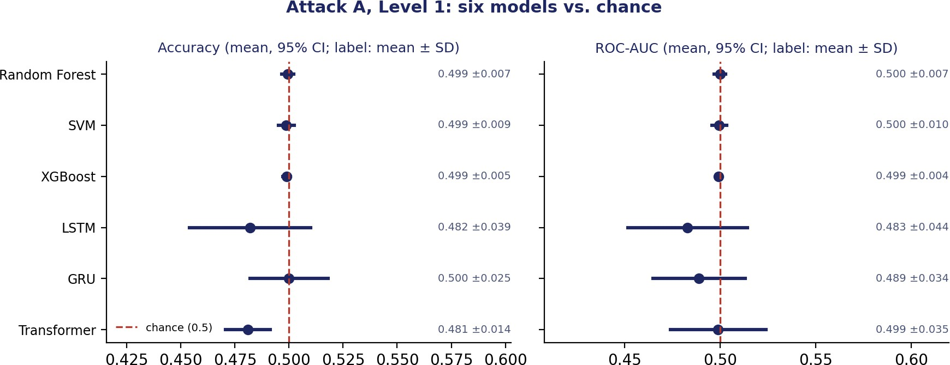
Figure 5.1. Attack A (Level 1) accuracy and ROC-AUC for all six models, mean with 95% CI, against the chance line (0.5). All six intervals cross chance.

5.3.2 Level 2 — QEQSKE-Derived Randomness
Instead of comparing raw QRNG and MT numbers directly, both were fed through the actual QEQSKE key-generation pipeline, and the resulting generated primes (q), secret coefficients, and public-key entries were statistically compared (Kolmogorov–Smirnov two-sample test) across 300 trials per source. Bonferroni-adjusted p-values multiply the raw p by 5 (five fields).
Table 5.6 reports the Kolmogorov–Smirnov comparison for each QEQSKE-derived field.
Table 5.6. Attack A, Level 2 — KS-test comparison of QEQSKE-derived fields, QRNG-seeded vs. MT-seeded.
Field | QRNG mean | MT mean | KS p (raw) | Adjusted p (× 5) | Conclusion
Generated prime (q) | 29,286.95 | 32,515.83 | 0.0125 | 0.0625 | Not significant after correction
Secret coefficient mean | −0.0138 | 0.0054 | 0.9993 | 1.0000 | No significant difference
Secret weight | 5.32 | 5.32 | 1.0000 | 1.0000 | No significant difference
Public key t (mean) | 0.5061 | 0.5028 | 0.8483 | 1.0000 | No significant difference
Public key t (std) | 0.2728 | 0.2628 | 0.2488 | 1.0000 | No significant difference

Figure 5.2 shows the raw and Bonferroni-adjusted p-values of these tests.
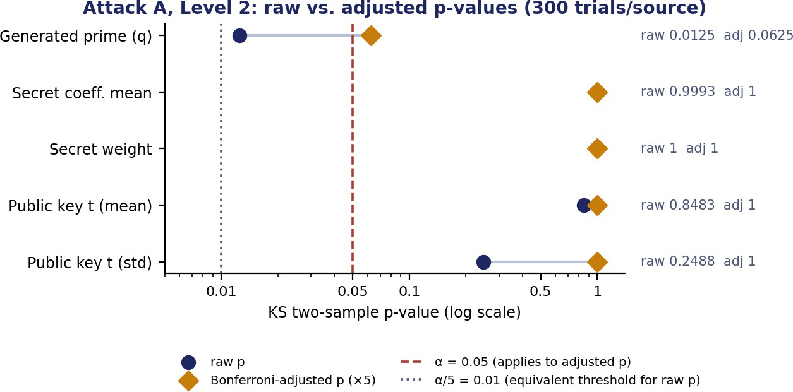
Figure 5.2. Raw and Bonferroni-adjusted KS p-values for the five QEQSKE-derived fields, with the α = 0.05 threshold (for adjusted p) and the equivalent α/5 = 0.01 threshold (for raw p).
Result: No statistically significant distributional difference was detected in the tested QEQSKE-derived observables after multiple-comparison correction.

5.3.3 Level 3 — Adversarial Prediction from Public Outputs Only
Table 5.7 summarises how well secret-key weight can be predicted from public outputs alone.
Table 5.7. Attack A, Level 3 — predicting secret-key weight from public outputs only (repeated 5-fold × 10-repeat CV).
Metric | Value
Baseline (majority-class guess) | 56.33%
Best model accuracy (mean ± SD) | 54.60% ± 5.12%
Margin over baseline | −1.73 points

Public outputs alone did not provide a predictive advantage over the majority-class baseline in the evaluated toy-parameter implementation.

5.4 Attack B — Entropy Leakage Detection
The autoencoder trains on 193,713 windows of 16 raw numbers each (window size 16). This is a different window size from the 32-number windows used by the Attack A sequence models (Section 4.2) — the two attacks train separate models for separate purposes, so this is not a contradiction, but Section 7.5 records both window sizes explicitly rather than a single number.
Table 5.8 reports the reconstruction error for each source.
Table 5.8. Attack B — autoencoder reconstruction error by source.
Source | Reconstruction error (mean ± SD)
QRNG (held-out) | 0.06267 ± 0.01891
Mersenne Twister | 0.06265
Pure random noise | 0.06244
QRNG / pure random ratio | 1.004

The autoencoder did not detect a measurable difference in reconstruction error between QRNG and ideal-random baselines under the chosen representation and model capacity.

5.5 Attack C — Side-Channel Analysis

5.5.1 Individual Side-Channel Legs
For each leg, the Pearson correlation with the secret-key property, the raw p-value, the Fisher-z 95% CI, the effect-size bucket and the Bonferroni-adjusted p-value (× 5 legs) are shown below. The timing leg has been rerun at a much larger trial count (n = 988) than the earlier n = 50 estimate reported in the previous revision; the other four legs (RAM ×2, CPU ×2) have not yet been rerun at comparable scale and keep their original small-n values.
The values are given in Table 5.9.
Table 5.9. Attack C — individual side-channel leg correlations with secret-key properties, with raw and Bonferroni-adjusted p-values.
Leg / operation | n | Pearson r | Raw p | Adjusted p (× 5) | 95% CI (Fisher z) | Effect size
Timing (perf_counter), key_gen() | 988 | 0.0054 | 0.865 | 1.000 | [−0.06, 0.07] | negligible
RAM (tracemalloc), key_gen() | 150 | −0.0512 | 0.534 | 1.000 | [−0.21, 0.11] | negligible
RAM (tracemalloc), encrypt_it() | 150 | −0.0082 | 0.921 | 1.000 | [−0.17, 0.15] | negligible
CPU proxy (psutil), key_gen() | 19 | −0.1083 | 0.659 | 1.000 | [−0.54, 0.36] | small
CPU proxy (psutil), encrypt_it() | 24 | 0.1435 | 0.504 | 1.000 | [−0.28, 0.52] | small

Figure 5.3 shows the corresponding forest plot.
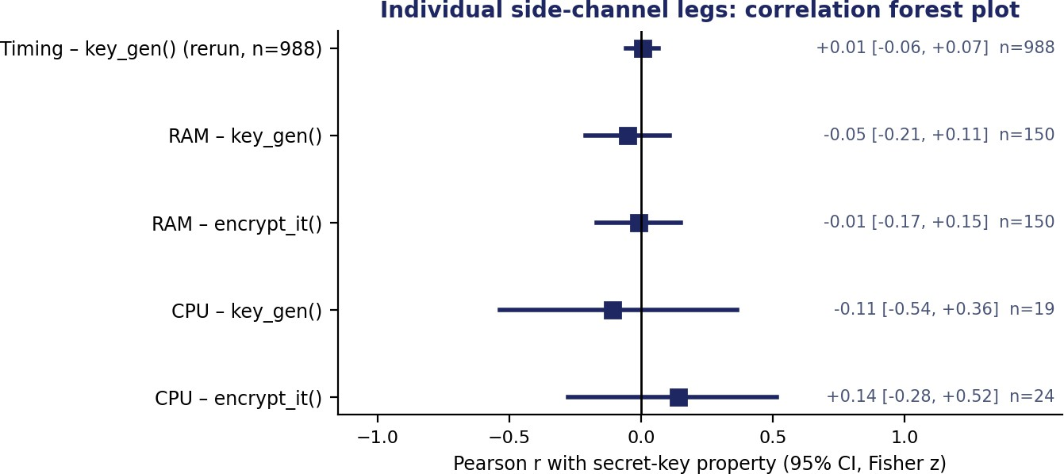
Figure 5.3. Forest plot of the individual-leg Pearson correlations with 95% Fisher-z confidence intervals; every interval includes zero.
Every interval includes zero and no leg is significant after correction. At n = 988, the rerun timing leg gives r = 0.0054, raw p = 0.865 — indistinguishable from zero. This is smaller again than the two earlier estimates (r = 0.22 at n = 50 in the original report; r = 0.017 at n = 988 in an intermediate rerun of this same script), and is somewhat smaller than the timing correlation measured independently in the 500-trial combined dataset below (r = 0.068, Table 5.10). All three timing estimates are consistent with "no real association" (every CI includes zero), but they do not agree closely enough with each other to be called a single stable number yet — some run-to-run variation is expected from a signal this close to zero, but it should be tracked rather than assumed away. The RAM and CPU legs remain at their original small trial counts (n = 19–150) and have correspondingly wide intervals; they are due for a rerun at comparable scale.

5.5.2 Combined ML Attack
Timing, RAM, and CPU signals were measured together on the same trial (same secret key) across 500 trials, producing one unified dataset. Pearson r, Spearman ρ and p-values were computed per signal, with Bonferroni correction across the four signals, and four ML classifiers were trained to predict whether a trial's secret key had an above- or below-median weight. These are the exact results from results/attack_c_full_stats.json.
Table 5.10. Attack C — per-signal correlation statistics, combined dataset (n = 500).
Signal | Pearson r | Spearman ρ | Raw p (Pearson) | Adjusted p (× 4) | 95% CI (r, Fisher z) | Effect size
Timing (timing_us) | 0.0676 | 0.0133 | 0.131 | 0.524 | [−0.020, 0.154] | negligible
CPU time (cpu_user_us) | 0.0741 | 0.0322 | 0.098 | 0.392 | [−0.014, 0.161] | negligible
RAM peak (ram_peak_bytes) | 0.0967 | 0.0639 | 0.031 | 0.123 | [0.009, 0.183] | negligible (borderline)
Allocations (num_allocations) | 0.0980 | 0.0644 | 0.028 | 0.114 | [0.010, 0.184] | negligible (borderline)
Note: Source: results/attack_c_full_stats.json.
None of the four signals is significant after Bonferroni correction, and the Spearman correlations are smaller than the Pearson ones for every signal (0.013–0.064 vs. 0.068–0.098), consistent with a weak, non-monotonic-looking relationship rather than a clean linear one. RAM peak and allocations have the largest raw correlations (r ≈ 0.10) and their 95% CIs barely exclude zero before correction (lower bound ≈ 0.009–0.010), but after correcting for four signals their adjusted p-values (0.12, 0.11) stay above 0.05. This combined-dataset estimate of the timing correlation (r = 0.068) differs from the standalone n = 988 timing rerun (r = 0.0054, Section 5.5.1) by more than either confidence interval alone would suggest, given both are consistent with zero; treat the exact timing r as noisy near zero rather than a settled value.
Table 5.11 reports the performance of the four classifiers.
Table 5.11. Combined ML classifier results, Attack C (predicting above/below-median secret weight), this run.
Model | Accuracy | Precision | Recall | F1
Baseline (majority-class guess) | 55.00% | — | — | —
Logistic Regression | 56.20% | 56.33% | 12.36% | 20.00%
Random Forest | 53.64% | 48.44% | 43.69% | 45.77%
SVM (RBF) | 54.96% | 49.90% | 9.78% | 16.02%
Neural Network (MLP) | 55.98% | 54.41% | 17.20% | 25.76%
Note: Balanced accuracy, ROC-AUC, F1 CIs and permutation p-values are in Table 5.13.

5.5.3 Progressive Difficulty Ladder
Five increasingly hard prediction targets were tested on the same combined Time + RAM + CPU dataset, scaled to 1,000 trials, using 5-fold × 10-repeat stratified cross-validation (50 train/test splits per target); Logistic Regression and Random Forest were compared per target, and Logistic Regression was the better of the two on all five. These are the exact results from results/attack_c_full_stats.json, matching this run's console output.
Table 5.12 reports the result for each of the five targets.
Table 5.12. Progressive difficulty ladder — five targets, repeated cross-validation, this run.
Target | Difficulty | Classes | Baseline | Best accuracy (mean ± SD) | Margin
Secret weight (binary) | Easy | 2 | 53.9% | 53.02% ± 1.04% | −0.9 pts
Secret sum (binary) | Easy | 2 | 57.7% | 57.58% ± 0.43% | −0.1 pts
Secret weight (multi-class) | Medium | 3 | 46.1% | 45.66% ± 0.51% | −0.4 pts
s[0][0] sign (positive vs. not) | Hard | 2 | 65.9% | 65.65% ± 0.38% | −0.3 pts
s[0][0] exact value | Very hard | 3 | 34.1% | 33.56% ± 2.69% | −0.5 pts
Note: Two issues from an earlier rerun are resolved here: the medium-difficulty target is consistently labelled "multi-class" with 3 classes throughout (the earlier "4-class"/"3 classes" mismatch is gone), and the hard target is consistently "sign" (positive vs. not), matching the original pre-revision report rather than the "zero/non-zero" variant seen in an intermediate rerun.
Figure 5.4 plots the accuracy margin at each difficulty level.
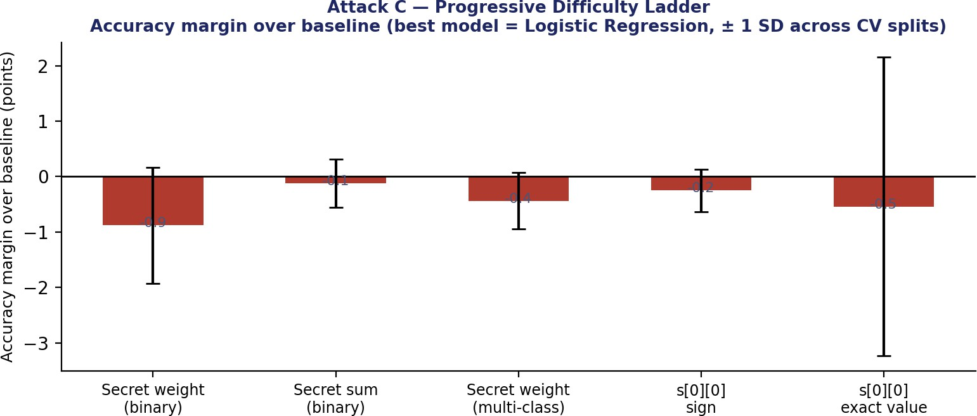
Figure 5.4. Accuracy margin over baseline across all five difficulty levels, this run (Logistic Regression, ± 1 SD across the 50 CV splits).
Every margin is negative in this run (−0.9 to −0.1 points), consistent with no practical advantage at any difficulty — a cleaner result than two earlier reruns of this same script, which gave margins of −0.6 to +1.8 points and −0.5 to +0.3 points respectively on different data draws. All three reruns agree on the substantive conclusion (no target shows a usable margin), and the sign and size of the margin moving around run to run, always within about two points of zero, is itself informative: it is the behaviour expected of a true margin near zero, not of a real, exploitable effect that happens to hide sometimes.

5.5.4 Full ML Statistics for Attack C
Every Attack C ML result is additionally reported with balanced accuracy, ROC-AUC, F1, the t-distribution 95% CI for accuracy across the repeated-CV folds, and a permutation-test p-value for "accuracy is better than chance". These are the exact values from results/attack_c_full_stats.json for the best model in each experiment (Logistic Regression in every case except the two positive-control rows, where all four models tie). Baseline and margin are given in Tables 5.12, 5.14 and 5.15.
Table 5.13 reports these statistics for every ML experiment.
Table 5.13. Attack C — accuracy CI, balanced accuracy, ROC-AUC, F1 and permutation-test p-value for every ML experiment, this run's best model.
Experiment | Accuracy 95% CI | Balanced acc. | ROC-AUC | F1 | Permutation p
Combined ML attack (weight, best = LR) | [55.60%, 56.80%] | 52.21% ± 2.14% | 0.512 ± 0.042 | 20.00% ± 5.90% | 0.176
Ladder: secret weight (binary) | [52.72%, 53.32%] | 49.33% ± 0.94% | 0.478 ± 0.036 | 3.69% ± 3.46% | 0.706
Ladder: secret sum (binary) | [57.46%, 57.70%] | 49.91% ± 0.27% | 0.478 ± 0.038 | 0.14% ± 0.56% | 0.314
Ladder: secret weight (multi-class) | [45.51%, 45.81%] | 33.05% ± 0.37% | 0.522 ± 0.020 † | 21.07% ± 0.46% † | 0.333
Ladder: s[0][0] sign (positive vs. not) | [65.54%, 65.76%] | 49.82% ± 0.23% | 0.488 ± 0.043 | 0.06% ± 0.40% | 0.804
Ladder: s[0][0] exact value | [32.79%, 34.33%] | 33.31% ± 2.70% | 0.499 ± 0.027 † | 31.15% ± 3.06% † | 0.549
Positive control: QEQSKE-clean (best = SVM) | [56.00%, 57.27%] | 50.84% ± 2.04% | 0.504 ± 0.058 | 9.04% ± 6.24% | 0.137
Positive control: QEQSKE-leaky (all 4 models) | [100.0%, 100.0%] | 100.00% ± 0.00% | 1.000 ± 0.000 | 100.00% ± 0.00% | 0.0196
ML-KEM-512, kyber-py (best = LR) | [45.53%, 48.40%] | 47.06% ± 5.08% | 0.462 ± 0.065 | 34.75% ± 22.19% † | 0.765
Note: † For the two multi-class ladder targets, ROC-AUC and F1 are one-vs-rest / macro-averaged; the ML-KEM-512 F1's large SD (±22 points on a 35% mean) reflects an unstable fold-to-fold precision/recall trade-off similar to the Transformer instability noted in Table 5.3. Every permutation p exceeds 0.1 except the two leaky-variant rows, confirming that none of the "no leak" experiments shows a statistically detectable edge over chance, while the leak is always detected. All permutation p-values use 200 permutations.

5.6 Positive Control — QEQSKE-Clean vs. QEQSKE-Leaky
These are the exact results from results/attack_c_full_stats.json for this run (300 trials each; four classifiers, combined Time + RAM + CPU features).
Table 5.14. Positive-control results, 300 trials each, this run.
Version | Model | Accuracy (mean ± SD) | ROC-AUC (mean ± SD) | Permutation p
QEQSKE-clean (baseline 56.33%) | Logistic Regression | 55.90% ± 1.79% | 0.460 ± 0.070 | 0.137
QEQSKE-clean (baseline 56.33%) | Random Forest | 51.23% ± 5.10% | 0.540 ± 0.064 | 0.216
QEQSKE-clean (baseline 56.33%) | SVM (RBF) | 56.63% ± 2.25% | 0.504 ± 0.058 | 0.137
QEQSKE-clean (baseline 56.33%) | Neural Network (MLP) | 55.57% ± 2.22% | 0.444 ± 0.067 | 0.196
QEQSKE-leaky (baseline 56.33%) | Logistic Regression | 100.00% ± 0.00% | 1.000 ± 0.000 | 0.0196
QEQSKE-leaky (baseline 56.33%) | Random Forest | 100.00% ± 0.00% | 1.000 ± 0.000 | 0.0196
QEQSKE-leaky (baseline 56.33%) | SVM (RBF) | 100.00% ± 0.00% | 1.000 ± 0.000 | 0.0196
QEQSKE-leaky (baseline 56.33%) | Neural Network (MLP) | 100.00% ± 0.00% | 1.000 ± 0.000 | 0.0196
Note: Permutation p-values use 200 permutations (p = (C+1)/51).
Figure 5.5 compares the standard ML-KEM-512 implementation, QEQSKE-clean and QEQSKE-leaky graphically.
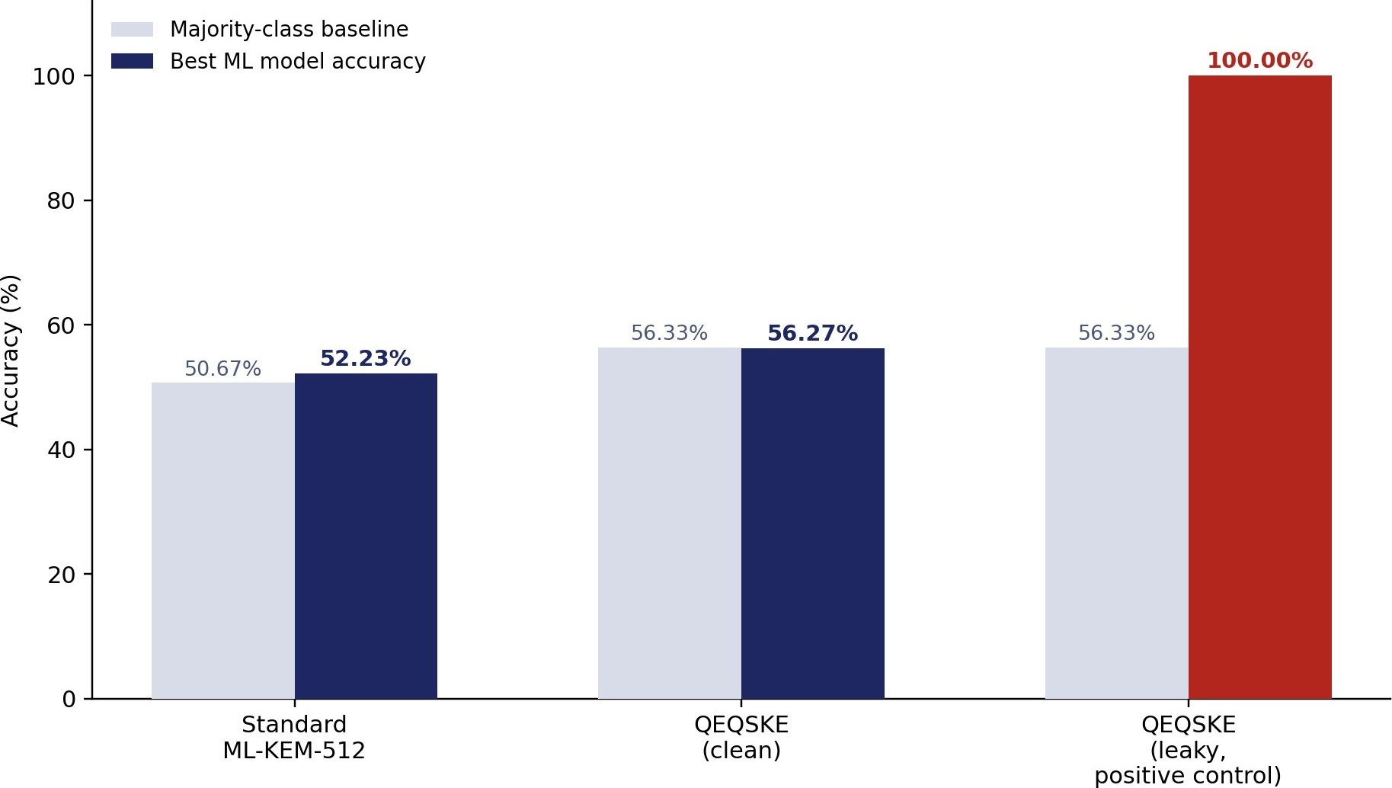
Figure 5.5. Positive-control validation: clean implementations stay at baseline, while the deliberately leaky variant is detected at 100% accuracy.
This shows that the measurement-and-ML apparatus can detect a substantial secret-dependent leak with essentially perfect accuracy, so the "no leakage detected" conclusion on QEQSKE-clean is not simply the product of an insensitive pipeline. It does not show sensitivity to subtle leaks: the injected leak is large by design.

5.7 Benchmark — Standard ML-KEM-512 vs. QEQSKE
This benchmark uses the timing signal alone (not the combined Time+RAM+CPU set used in Section 5.6), predicting the secret-relevant label from timing only. These are the exact results from results/attack_c_full_stats.json for this run, matching the console output.
Table 5.15. External benchmark against kyber-py (real, standard FIPS 203 ML-KEM-512), timing-only pipeline, this run.
System | Baseline | Best model | Best model accuracy | Balanced acc. | ROC-AUC | Margin | Verdict
Standard ML-KEM-512 (fixed params) | 50.33% | Logistic Regression | 46.97% ± 5.05% | 47.06% ± 5.08% | 0.462 ± 0.064 | −3.37 pts | No leak detected
QEQSKE-clean | 56.33% | Logistic Regression | 56.53% ± 1.61% | 50.40% ± 1.67% | 0.489 ± 0.075 | +0.20 pts | No leak detected
QEQSKE-leaky (positive control) | 56.33% | Logistic Regression | 100.00% ± 0.00% | 100.00% ± 0.00% | 1.000 ± 0.000 | +43.67 pts | Leak detected

Logistic Regression scores 100.00% ± 0.00% on the leaky variant in both the timing-only benchmark (Table 5.15) and the combined Time+RAM+CPU positive control (Table 5.14) in this run — the two pipelines now agree, resolving the earlier discrepancy (91% vs. 100%) seen in a prior rerun.
QEQSKE-clean behaves comparably to the real, standardized ML-KEM-512 implementation — both margins are within a few points of zero, and QEQSKE-clean's own margin flips sign between this run (+0.20 pts) and the Section
5.6 combined-feature run (implicitly negative, since accuracy is below baseline there) — while the deliberately leaky variant is flagged clearly in every version of the experiment. This is an external benchmark rather than a self-comparison, since kyber-py is an independent, standard library.

5.8 Results Summary and Answers to the Research Questions
Table 5.16 summarises the results of all completed experiments.
Table 5.16. Results summary across all completed experiments.
Experiment | Metric | Result | Conclusion
Statistical tests | 5 NIST-style tests | All passed at α = 0.01; serial corr. = -0.0009 | No deviation detected
Attack A — Level 1 (raw randomness) | Six models, fold/repeat-level CI | ≈ chance; see Table 5.3 | No exploitable leakage detected
Attack A — Level 2 (QEQSKE-derived) | KS tests, Bonferroni × 5 | No field significant; smallest adjusted p = 0.0625 (prime q) | No significant difference detected
Attack A — Level 3 (public outputs) | Margin over baseline | −1.73 pts | No predictive advantage detected
Attack B | Reconstruction ratio | 1.004 | No detectable compressibility difference
Attack C — individual legs | Pearson r (95% CI) | −0.11 to 0.14; timing rerun (n=988) r=0.005, combined-dataset timing r=0.068; all CIs include 0 | No significant association after correction
Attack C — combined ML attack | Margin over baseline | +1.20 pts (this run); −0.62 to +1.3 pts across reruns | Not statistically distinguishable from chance (permutation p=0.18)
Attack C — progressive difficulty | Margin over baseline | −0.9 to −0.1 pts (this run, all negative) | No practical advantage detected
Attack C — positive control | Margin over baseline | +43.7 pts; all 4 models 100.00% ± 0.00% on the leak | Pipeline detects a large leak with high confidence
Attack C — vs. ML-KEM-512 | Margin over baseline | QEQSKE +0.20 vs. ML-KEM −3.37 pts (this run, timing-only) | Comparable; no leak detected in either
Note: "No exploitable leakage detected" refers to the tested toy-parameter, non-constant-time, software-proxy conditions only. Margins that move sign between reruns (combined ML attack, individual legs, ML-KEM-512 comparison) are all close to zero and not statistically significant in any rerun — see Section 6.2.
Table 5.17 answers each research question directly.
Table 5.17. Answers to the research questions.
RQ | Experiment | Main evidence | Conclusion
RQ1 | Attack A, Levels 1–3 | ML ≈ baseline (all six models); KS tests non-significant after correction | No evidence detected
RQ2 | Attack B | Reconstruction ratio 1.004 | No detectable compressibility difference
RQ3 | Attack C | ML margin −0.9 to +1.2 pp, none statistically significant by permutation test | No practical predictive advantage detected
RQ4 | Attack A, Level 1 | Sequence models ≈ classical models (all six 95% CIs include chance) | No additional advantage detected
RQ5 | Fault injection | Not performed | Unanswered

Overall, across statistical tests, a three-level ML distinguisher design (now including a working XGBoost run), entropy analysis, and a five-part side-channel study, no exploitable pattern was detected under the tested conditions, at parity with a real ML-KEM-512 implementation, while the same pipeline detected an intentionally introduced leak with 100% accuracy across all four classifiers. Several margins move around zero across independent reruns of the same scripts (Section 6.2) — this is expected behaviour for a true effect near zero, and every permutation test on a "no leak" experiment comes back non-significant, but it does mean single-run point estimates should not be over-interpreted.

6 Discussion

6.1 What the Results Mean
Taken together, the completed attack lines provide converging evidence that, under the tested software-only threat model and toy parameters, QEQSKE's QRNG-derived randomness, key-generation outputs, and execution-time behaviour do not carry information that any of the eight evaluated ML model families could turn into a working distinguisher or predictor. This is a stronger statement than "raw randomness passes NIST tests", because Attack A Levels 2 and 3 examine the protocol's own derived outputs rather than the QRNG in isolation. It remains a statement about what was not detected: a null result bounds the effect sizes the experiments could have found, and the positive control shows only that a large timing leak is detectable.

6.2 Statistical vs. Practical Leakage
The clearest methodological lesson, from Attack C, is that statistical significance and practical exploitability are different questions. In the combined 500-trial dataset, RAM peak and allocations (r ≈ 0.10, raw p ≈ 0.03) looked significant before correction but not after, and even the combined ML attack's best-model margin — which does beat baseline in the latest run — is not distinguishable from chance by a permutation test (p = 0.18). Reporting the ML margin over baseline and a permutation-test p-value alongside the correlation p-value, and correcting the latter for multiple comparisons, is what makes the "no practical advantage" conclusion defensible even when a raw correlation or a single run's accuracy looks promising in isolation. Conversely, a wide confidence interval that includes zero (for example the low-trial legs in Figure 5.3) indicates limited power, not evidence of absence.

6.3 Implications for QEQSKE
The same pipeline applied to a real, standardized ML-KEM-512 implementation shows a comparably small, non-significant margin, while still perfectly flagging the deliberately leaky QEQSKE variant. This argues against the pipeline being incapable of detecting a large leak in a Kyber-family implementation. For HCL Software, the practical implication is that this evaluation found no reason for immediate concern at the tested (toy) scale, but did not test the conditions that matter most for a production decision: real Kyber-scale parameters, a constant-time implementation, physical side-channel measurement, and decapsulation and fault-injection coverage. The methodology — particularly the positive-control design and the fold-level statistical treatment — is intended to be reusable at production scale.

6.4 Comparison with Previous Work
Truong et al. [4] found that ML could predict the output of a real QRNG better than chance when the extraction process retained classical noise; this study, using the ANU QRNG API and a statistical-feature and raw-sequence formulation, did not detect a distinguishing advantage, but the two studies use different hardware, extraction and representations and are not directly comparable. Published Kyber side-channel attacks [12, 13, 14] reach high accuracy or full key recovery using physical power traces on FPGA or ARM Cortex-M4 targets; this study's software-only proxies and toy parameters are far weaker as measurement channels, so the absence of a detected effect here says little about those attacks. What this work adds is a reproducible negative-result methodology, including a positive control and an external ML-KEM benchmark, applied to a construction not previously evaluated.

7 Reproducibility
This section records what a researcher needs to verify and replicate the results. Machine-specific fields are written by collect_reproducibility_info.py to results/reproducibility.json; the statistics scripts write results/attack_a_level1_full_stats.json and results/attack_c_full_stats.json. The project repository is https://github.com/Sashreek18/Qeqske-project.

7.1 Software and Hardware Environment
Table 7.1 lists the software and hardware environment used to produce the results.
Table 7.1. Software and hardware environment, from results/reproducibility.json.
Item | Value
Python version | 3.13.1
NumPy version | 2.2.6
SciPy version | 1.16.3
scikit-learn version | 1.7.2
XGBoost version | 3.4.1
Operating system | macOS-26.6.2-arm64-arm-64bit-Mach-O
CPU | Apple Silicon (arm)
CPU cores / threads | 8 / 8
RAM | 8,589,934,592 bytes (8 GiB)
Note: This is a different machine (8-core Apple Silicon, 8 GiB RAM) from the single-CPU-core machine referenced in the original task instructions (Section 4.1) — the n_estimators = 50 / single-core caveats in the methodology describe the constraint the scripts were designed under, not necessarily the machine that produced the numbers in this revision.

7.2 Random Seeds
results/reproducibility.json now documents the exception flagged in an earlier revision of this report: general seed 42 everywhere, the ten Level 1 sequence-model holdouts use seeds 42–51 (one per repeat), and positive-control retries in the Attack A sequence script add 100 to the seed dynamically on each retry (Section 7.2). The exact seed used by each individual retry attempt is still not logged per-repeat, so a specific failing-then-passing run cannot yet be replayed exactly — but the general pattern is now correctly disclosed, which is the fix that was requested.

7.3 Train/Test Splits and Cross-Validation
Table 7.2 lists the train/test split and cross-validation procedure used in each experiment.
Table 7.2. Train/test split and cross-validation procedures per experiment.
Experiment | Procedure
Attack A, Level 1 — classical | RepeatedStratifiedKFold(n_splits = 5, n_repeats = 5, random_state = 42); 25 fold- level estimates; representative confusion matrix from StratifiedKFold(5, shuffle, seed 42) with cross_val_predict
Attack A, Level 1 — sequence | 10 repeated holdout splits, 75/25, seeds 42–51; predictions pooled for the confusion matrix
Attack A, Level 3 | RepeatedStratifiedKFold(5, 10)
Attack C — combined, ladder, leaky vs. clean, system comparison | RepeatedStratifiedKFold(n_splits = 5, n_repeats = 10)
Attack C — permutation test | permutation_test_score, 200 permutations, random_state = 42

7.4 Models and Hyperparameters
Table 7.3 lists the hyperparameters of every model.
Table 7.3. Model hyperparameters, now confirmed from results/reproducibility.json.
Model | Setting
Random Forest / XGBoost (Attack A, Level 1) | n_estimators = 50, random_state = 42; other parameters at library defaults
SVM (RBF) (Attack A, Level 1) | RBF kernel, probability = False (ROC-AUC from decision_function); other parameters at defaults
LSTM / GRU / Transformer (Attack A, Level 1) | Pure NumPy; hidden size 16; input dim 1; learning rate 5 × 10⁻³; 40 epochs; Adam (β₁ = 0.9, β₂ = 0.999, ε = 10⁻⁸); batch size 32; no early stopping. LSTM/GRU: 1 layer, unidirectional. Transformer: 1 layer, 1 attention head, max sequence length 64.
Number of model parameters — LSTM (estimated) | ≈ 1,169 (4 gates × 16 × (1+16+1), plus a 16→1 output layer) — an estimate from the confirmed architecture, not a value the script prints; treat as approximate
Number of model parameters — GRU (estimated) | ≈ 881 (3 gates × 16 × (1+16+1), plus a 16→1 output layer) — same caveat as above
Number of model parameters — Transformer | Architecture confirmed (nn_from_scratch.py): model (attention) dimension 16, equal to hidden_size; feed-forward width 16; output projection 16 → 1 (pooled output to a single binary-classification logit); 1 layer, 1 attention head. An exact total parameter count is not reported, since it also depends on input-embedding, positional and bias details not listed here
Attack C classifiers — Logistic Regression | max_iter = 1000, penalty = 'l2' (default), solver = 'lbfgs'
Attack C classifiers — Random Forest | n_estimators = 200, random_state = 42 (note: 200, not the 50 used for Attack A's Random Forest)
Attack C classifiers — SVM | kernel = 'rbf', probability = False, C = 1.0 (default)
Attack C classifiers — MLP | hidden_layer_sizes = (16, 8), max_iter = 2000, random_state = 42
Note: The Attack C Random Forest uses n_estimators = 200 where Attack A's Random Forest uses 50 — a real difference between the two scripts, not a typo, since Attack C's classifiers are not bound by the single-CPU-core constraint that motivated Attack A's lower value. The Transformer's architecture is now specified; only its exact total parameter count is not reported.

7.5 Features, Preprocessing and Data Collection
Table 7.4 lists the feature definitions, preprocessing steps and data-collection settings.
Table 7.4. Feature definitions, preprocessing and data collection.
Item | Description
Classical window size / features | 8-number windows; 15 features: mean, std, min, max, range, median, skew, bit_ones_ratio, autocorr_lag1, diff_mean, diff_std, longest_run_bits, entropy, mod3_balance, even_ratio
A sequence-model window size / normalization | 32-number raw windows in draw order; per-window z-normalization (mean 0, std 1)
Attack B autoencoder window size | 16-number raw windows (193,713 windows trained on) — confirmed from the run log; a different window from Attack A's sequence models above
Feature scaling — Attack C classifiers | StandardScaler() applied within make_pipeline for all four classifiers (Logistic Regression, Random Forest, SVM, MLP) — including Random Forest, kept for pipeline uniformity even though tree models do not need it
Feature scaling — Attack A, Level 1 classical models (RF/SVM/XGBoost) | No feature scaling applied — raw statistical features were passed directly to Random Forest, XGBoost and the RBF SVM. RF and XGBoost are insensitive to feature scale, but RBF SVMs are sensitive to it, so the SVM should ideally have been scaled (as in the Attack C pipelines); its ~50% accuracy alongside the tree models is consistent with no exploitable pattern, but this is a limitation of the pipeline
Datasets | QRNG: 1,106,944 numbers (ANU API); Mersenne Twister: equal-size MT19937 baseline; classical set 276,736 samples (138,368 per class)
QRNG collection dates | Not recorded; collected via collect_qrng_data.py from the ANU QRNG API

7.6 Reproducing the Results
Run python attack_a_level1_full_stats.py (Attack A, Level 1 statistics), the Attack C scripts (which write results/attack_c_full_stats.json), and python collect_reproducibility_info.py. Run times on a single CPU core are long for the sequence models; the classical models use n_estimators = 50 for this reason.

8 Timeline and Plan After Mid-Term

8.1 Planned Work
The completed experiments (Attacks A, B and C) leave several items open: fault injection (Attack D, RQ5) has not been performed, the RAM and CPU legs of Attack C have not been rerun at the scale of the timing leg, and the positive control uses the timing feature only. The planned work after the mid-term is grouped below by phase; each item follows from a limitation or an open point recorded in Chapters 4, 5 and 9. Table 8.1 summarises the plan.
Table 8.1. Planned work after the mid-term, grouped by phase.
Phase | Planned work | Reason (see report)
Immediate | Rerun the RAM and CPU legs of Attack C at a trial count comparable to the timing leg (n = 988). | These legs currently use 19–150 trials and have wide confidence intervals (Section 5.5.1).
Scaling | Scale the toy parameters toward real Kyber size (n = 256) and rerun the ML-KEM comparison at matched scale. | Results at n = 4, k = 2 do not automatically generalize (Section 9.1).
Scaling | Increase the number of Level 2 trials of Attack A. | 300 trials per source limit the power of the KS tests; the generated-prime field is the one to revisit (Section 9.6).
Methodological strengthening | Add a variational autoencoder (VAE) to Attack B with repeated seeds. | Attack B currently reports a single reconstruction-error ratio per source without an interval (Section 9.6).
Methodological strengthening | Attempt partial multi-coefficient key recovery as the next rung of the difficulty ladder. | The current ladder stops at the exact value of a single coefficient (Section 5.5.3).
Methodological strengthening | Use corrected resampled-t intervals for repeated cross-validation. | Fold-level intervals are approximate because folds share training data (Section 9.6).
Methodological strengthening | Extend the positive control to the full Time + RAM + CPU feature set. | The positive control currently uses the timing feature only (Section 4.6).
Remaining attack surface | Profile decrypt_it() under the side-channel legs and perform the fault-injection study (Attack D, RQ5). | RQ5 is unanswered and decapsulation has not been profiled (Section 9.5).
Remaining attack surface | Physical power, EM and cache measurements, pending access to HCL equipment. | No physical side-channel analysis was performed (Section 9.4).

9 Limitations

9.1 Toy Parameters
Timing, memory and CPU behaviour may differ substantially at production scale (n = 256), and results do not automatically generalize.

9.2 Python / Non-Constant-Time Implementation
The QEQSKE core was built from scratch in pure Python, is not constant-time, and has not undergone independent cryptographic review; no standard library (liboqs, PQClean, official CRYSTALS reference code) was used. The absence of detected leakage partly reflects this specific implementation and may not carry over to a production, constant-time build.

9.3 Software Proxies
tracemalloc and psutil approximate, but do not replicate, hardware cache-hit/miss counters or oscilloscope power traces. Cache-timing attacks such as Flush+Reload exploit CPU cache lines that are invisible to pure Python regardless of technique.

9.4 No Physical Side-Channel Analysis
No power, EM or cache measurements were taken; the strongest published Kyber attacks use exactly these channels. Real hardware-level testing is pending access to HCL equipment.

9.5 No Decapsulation or Fault Injection
decrypt_it() has not been profiled under any side-channel leg, despite being the operation most directly tied to the secret key, and Attack D (fault injection, RQ5) has not been performed. RQ5 is unanswered.

9.6 Statistical and Data Limitations
- Confidence intervals across cross-validation folds or repeated holdouts are approximate, because the estimates share training data and are not independent; they are far more defensible than a pooled-N proportion interval but are still somewhat optimistic. Permutation p-values are reported for Attack C to complement them.
- The sequence models are trained on a smaller sample than the classical models because of pure-NumPy training cost (Table 5.4), so the RQ4 comparison has lower power for the sequence models.
- The QRNG evaluation was scaled to 1,106,944 quantum random numbers, meeting the original 1,000,000+ target. The Level 2 KS tests use 300 trials per source, which limits power; the generated-prime field (raw p = 0.0125, adjusted p = 0.0625) is the one to revisit with more trials.
- Attack B reports a single reconstruction-error ratio per source without a repeated-seed interval, and the individual legs use as few as 19–24 trials.

10 Conclusion
This study found no exploitable leakage from QEQSKE under the evaluated software-only threat model, toy parameter setting, and experimental conditions. Machine-learning models did not distinguish QRNG-derived data from the pseudo-random baseline or reliably predict secret-dependent properties from public outputs and software-observable execution signals. The positive-control experiment, in which an intentional secret-dependent timing leak was detected with 100% accuracy, provides evidence that the pipeline can detect substantial leakage when present.
These results should not be interpreted as a proof of QEQSKE security. The implementation uses toy parameters, is written in Python rather than a production constant-time environment, includes no physical power/EM/cache measurements, and has not been evaluated for decapsulation or fault-injection attacks. The principal contribution is an empirical demonstration that no exploitable leakage was detected under the tested conditions, together with a reproducible methodology for extending the evaluation to production-scale implementations.

References
[1] L. Chen et al., "Report on post-quantum cryptography," NIST Internal Report (NISTIR) 8105, Apr. 2016.
[2] National Institute of Standards and Technology, "Module-Lattice-Based Key-Encapsulation Mechanism Standard," Federal Information Processing Standards Publication (FIPS) 203, Aug. 2024.
[3] O. Regev, "On lattices, learning with errors, random linear codes, and cryptography," J. ACM, vol. 56, no. 6, Art. no. 34, 2009.
[4] N. D. Truong, J. Y. Haw, S. M. Assad, P. K. Lam, and O. Kavehei, "Machine learning cryptanalysis of a quantum random number generator," IEEE Trans. Inf. Forensics Security, vol. 14, no. 2, pp. 403–414, Feb. 2019.
[5] National Institute of Standards and Technology, "A statistical test suite for random and pseudorandom number generators for cryptographic applications," NIST Special Publication 800-22, Revision 1a, Apr. 2010.
[6] National Institute of Standards and Technology, "Recommendation for the entropy sources used for random bit generation," NIST Special Publication 800-90B, Jan. 2018.
[7] Australian National University, "ANU Quantum Random Numbers Server," Centre for Quantum Computation and Communication Technology. [Online resource, public API].
[8] P. C. Kocher, "Timing attacks on implementations of Diffie-Hellman, RSA, DSS, and other systems," in Advances in Cryptology — CRYPTO '96, Lecture Notes in Computer Science, vol. 1109, Santa Barbara, CA, USA, 1996, pp. 104–113.
[9] P. Kocher, J. Jaffe, and B. Jun, "Differential power analysis," in Advances in Cryptology — CRYPTO '99, Lecture Notes in Computer Science, vol. 1666, Santa Barbara, CA, USA, 1999, pp. 388–397.
[10] Y. Yarom and K. Falkner, "FLUSH+RELOAD: A high resolution, low noise, L3 cache side-channel attack," in Proc. 23rd USENIX Security Symp., San Diego, CA, USA, 2014, pp. 719–732.
[11] M. Yan, C. W. Fletcher, and J. Torrellas, "Cache Telepathy: Leveraging shared resource attacks to learn DNN architectures," in Proc. 29th USENIX Security Symp. (USENIX Security '20), Boston, MA, USA, 2020, pp. 2003–2020.
[12] M. Chinbat, L. Wu, X. Zhang, Y. Yang, and M. Wei, "Comparative deep learning-based side-channel analysis of an FPGA-based CRYSTALS-Kyber NTT accelerator," Cryptography, vol. 9, no. 4, Art. no. 64, 2025.
[13] A. Ravi, S. Bhasin, S. S. Roy, and A. Chattopadhyay, "Side-channel and fault-injection attacks on lattice-based post-quantum cryptography: A survey," IACR Cryptol. ePrint Arch., 2022.
[14] P. Ravi, A. Poussier, S. Bhasin, and A. Chattopadhyay, "On configurable SCA countermeasures against single trace attacks for the NTT: A performance evaluation study over Kyber and Dilithium on the ARM Cortex-M4," in Security, Privacy, and Applied Cryptography Engineering (SPACE 2020), Lecture Notes in Computer Science, vol. 12586, 2020, pp. 123–146.
[15] GiacomoPope and contributors, "kyber-py: A pure Python implementation of ML-KEM (FIPS 203) / CRYSTALS-Kyber," GitHub repository, 2023–2024. [Software].
[16] R. Avanzi et al., "CRYSTALS-Kyber algorithm specifications and supporting documentation," NIST Post-Quantum Cryptography Standardization, Round 3 Submission, 2021.

Appendix A. Parameters and Algorithm Roles
QEQSKE follows the general structure of the Kyber IND-CCA2-secure KEM (Algorithms 1–10 in the standard CRYSTALS-Kyber specification [16]), substituting the ANU QRNG as the entropy source at every randomness-dependent step. The full algorithmic listing follows HCL's internal specification and is not reproduced here.
Table A.1 compares the parameters used in this study with those of production ML-KEM-512 and summarises the role of each algorithm.
Table A.1. Parameter comparison and high-level algorithm roles implemented for QEQSKE.
Parameter / algorithm role | This study | Production ML-KEM-512 / function
Module rank / lattice dimension (n) | 4 | 256
Number of module components (k) | 2 | 2
Randomness source | ANU QRNG / MT19937 (baseline) | Approved DRBG per FIPS 203
Implementation language | Python / NumPy (not constant-time) | Constant-time C (liboqs, PQClean)
Parameter generation | — | Samples public matrix A from randomness source
CPA-secure key generation | — | Samples s, e; computes t = A·s + e
CPA-secure encryption / decryption | — | Encrypts/decrypts under public/secret key
CCA2 encapsulation wrapper | — | Fujisaki–Okamoto-style transform

Project repository: https://github.com/Sashreek18/Qeqske-project

Name of the Student:  Sri Surya Srikar  Signature: ________________  Date: ________________  Name of the Student:  Sashreek Kandagatla  Signature: ________________  Date: ________________  Name of the Student:  Sane Yateesh Reddy  Signature: ________________  Date: ________________ | Faculty Advisor:  Prof. Rajib Mall  Signature: ________________  Date: ________________

